# CS 255 System Design Document Template

## UML Diagrams

### UML Use Case Diagram

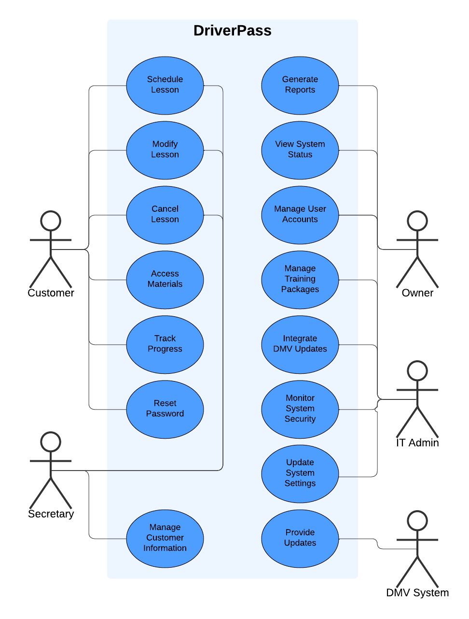

### UML Activity Diagrams

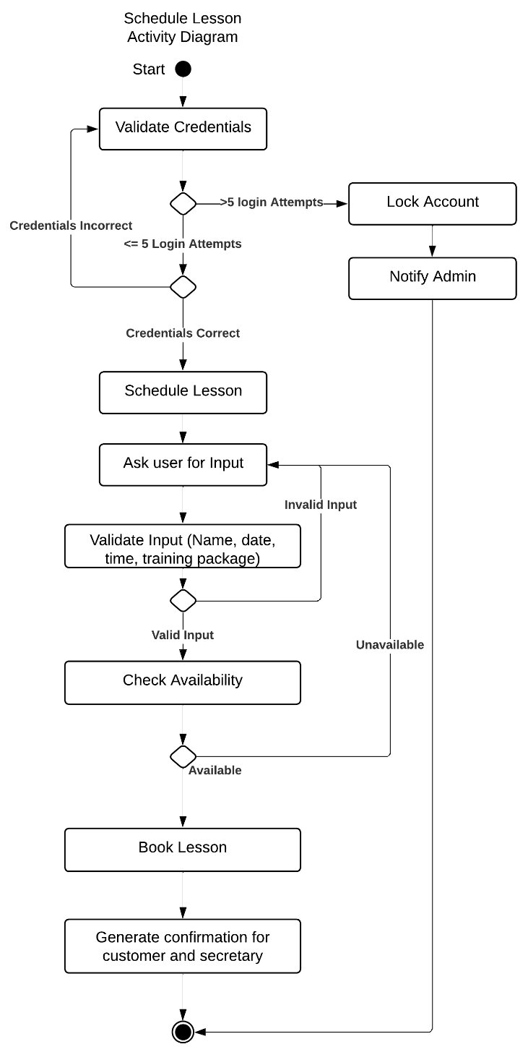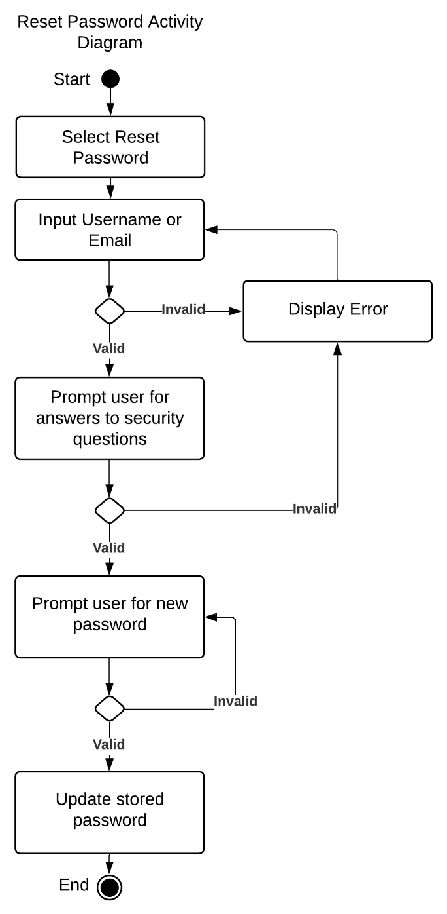

### UML Sequence Diagram

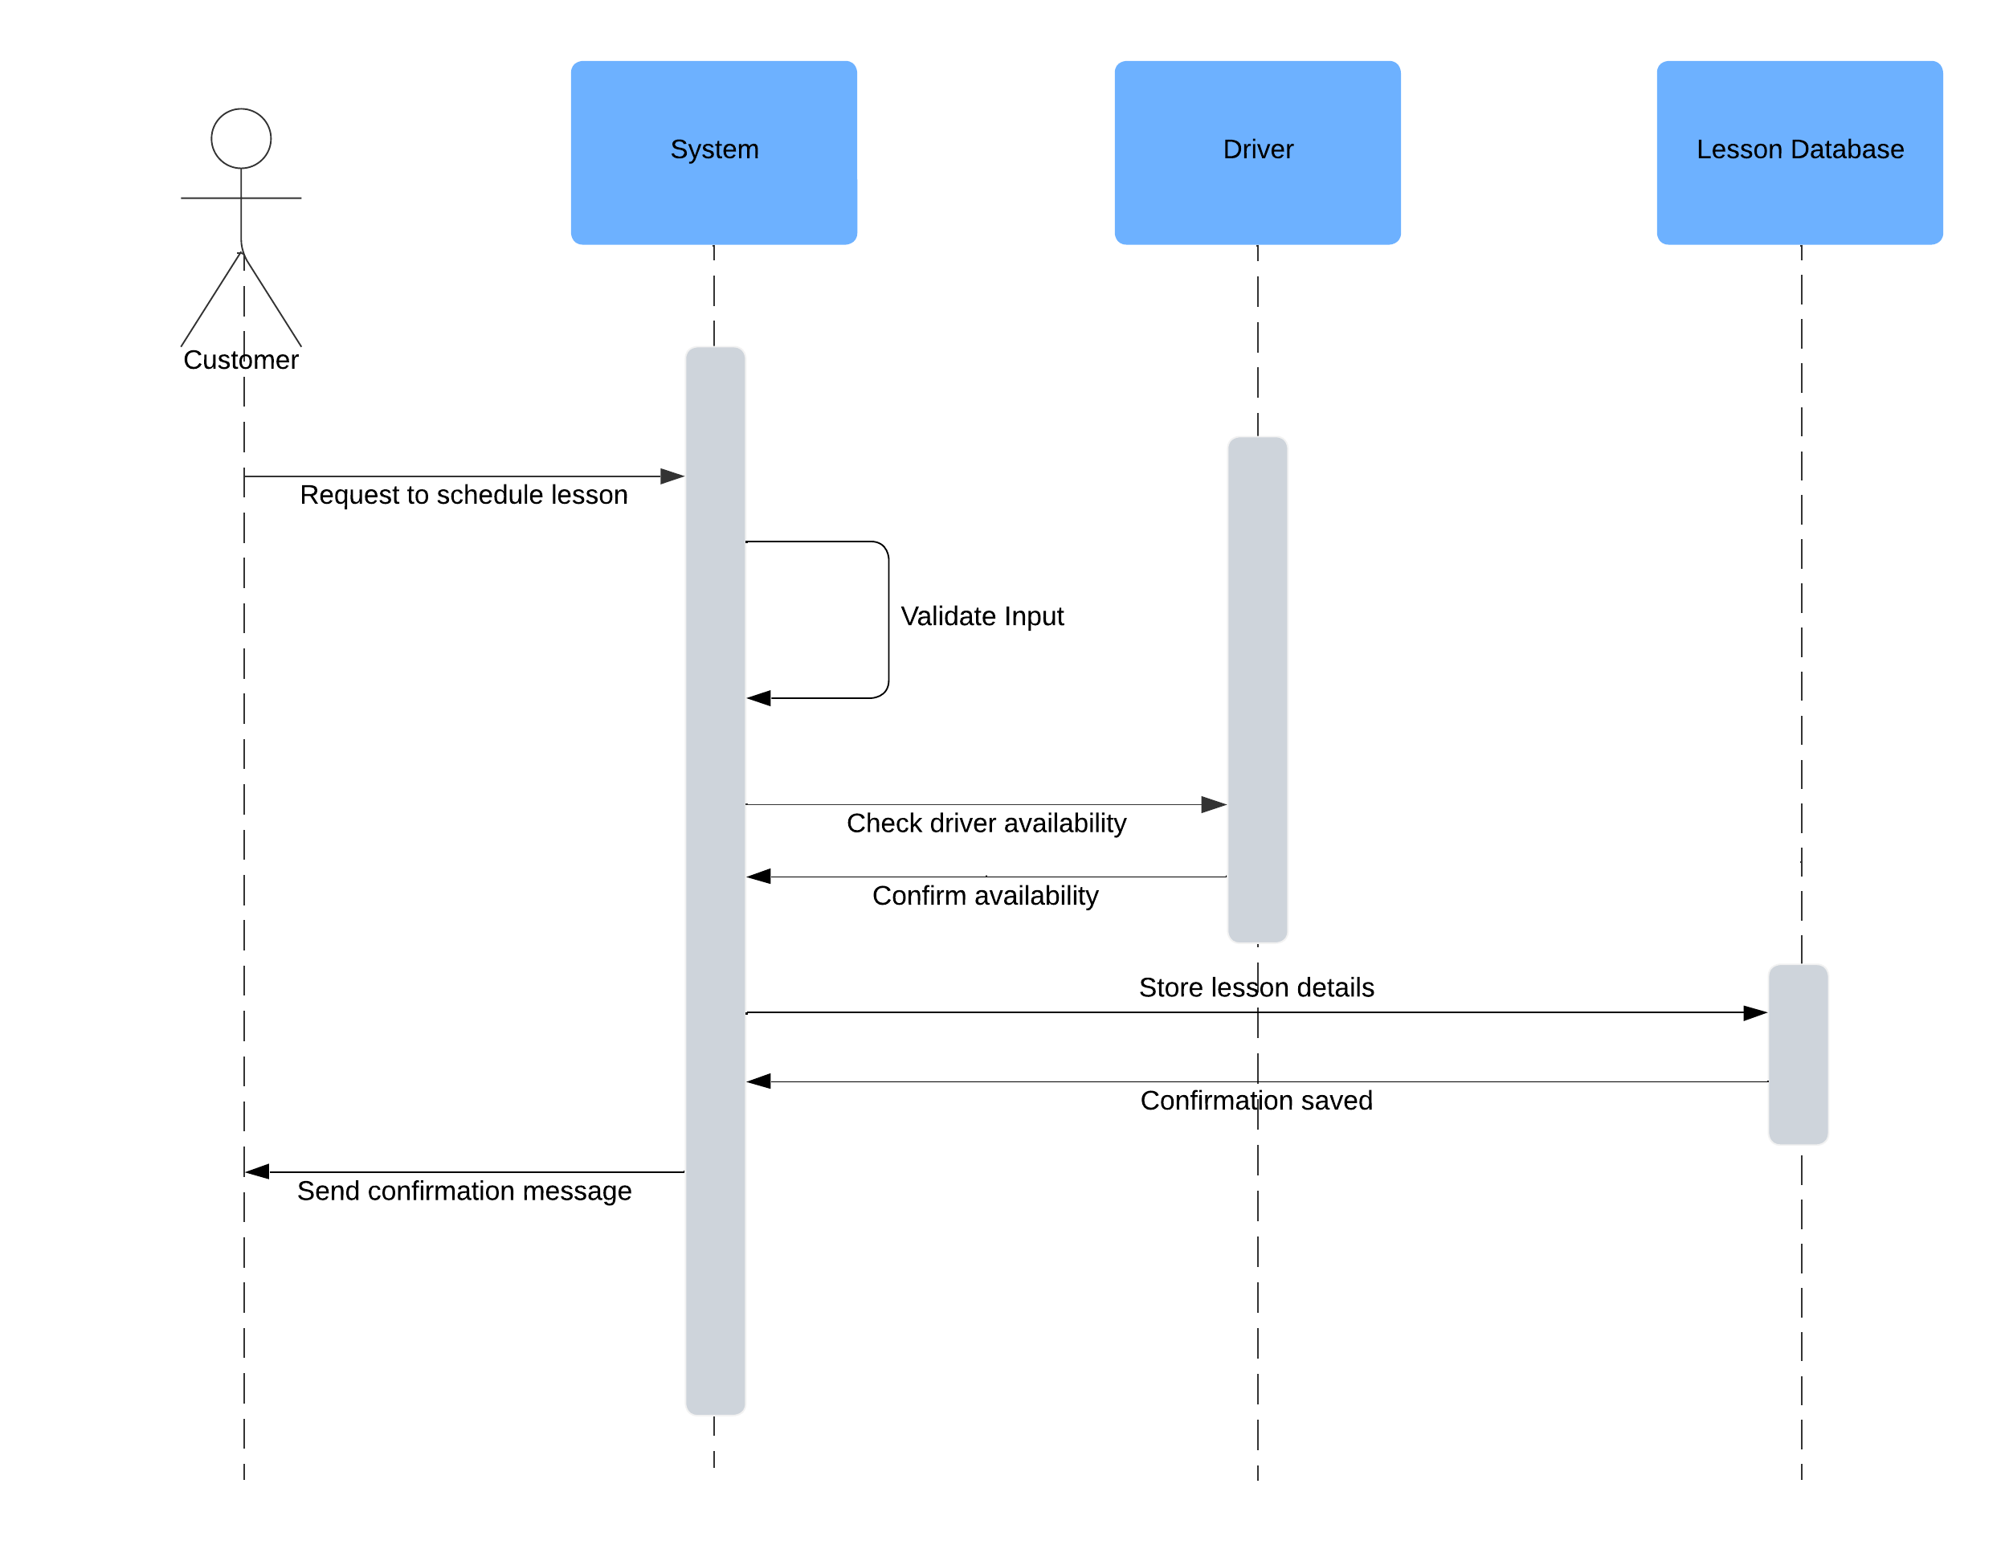

### UML Class Diagram

## Technical Requirements

To support the DriverPass system, several hardware, software, tools, and infrastructure components are necessary. A high-performance server is required to host the web-based application and manage customer requests efficiently. I recommend a server with a quad-core processor and at least 16 gigabytes of RAM (random access memory) to ensure smooth performance. Additionally, the server should support automated backups to prevent data loss in the event of a discrepancy or failure. For enhanced security and reliability, I suggest using a Linux-based server. Linux is open-source, highly customizable, and offers robust security features, minimizing exposure to mainstream vulnerabilities.

Several development tools are essential for building and maintaining the system:

* Git for version control and collaborative development,
* Eclipse for Java development, and
* Selenium for UI testing to ensure a smooth user experience.

Devices accessing the system will vary, including computers, laptops, and mobile devices. These devices should have access to modern web browsers, such as Google Chrome, Mozilla Firefox, or Safari, to ensure compatibility. High-speed internet is crucial for seamless interaction with the system, ensuring quick responses and efficient communication between users and the platform.

To maintain system security, encryption will be implemented between the client and server using SHA-256 encryption, ensuring password and data security during transmission. Additionally, role-based access controls (RBAC) will be used to restrict access to sensitive parts of the system, allowing only authorized users to perform administrative or high-level tasks.